Registration: Call the Shelby County Extension Office (205) 669-6764

Workshop cost: FREE for everyone!
(lunch will be served without charge)
  - , beginning or transitioning farmers

Wednesday, October 9, 2019, 10:00 AM – 1:00 PM
Speakers and Topics:
• Pest Detection & Management, Focusing on Exclusion and Bio-insecticides - Dr. Ayanava Majumdar, Extension Entomologist, Auburn University
• Observations with Organic Herbicides, Paper Mulch, Irrigation Monitoring, Cut-flower Production, Floating Row Covers and more - Kirk and Allison Creel of Blue Rooster Farms and Gary Gray, Regional Extension Agent

Location: Kirk and Allison Creel’s Blue Rooster Farms,
185 Leisure Lane, Sterrett, AL 35147

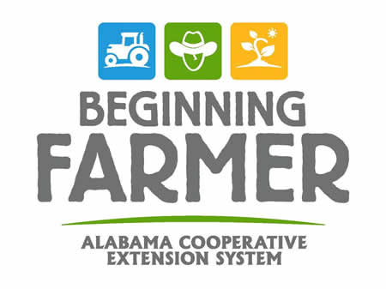
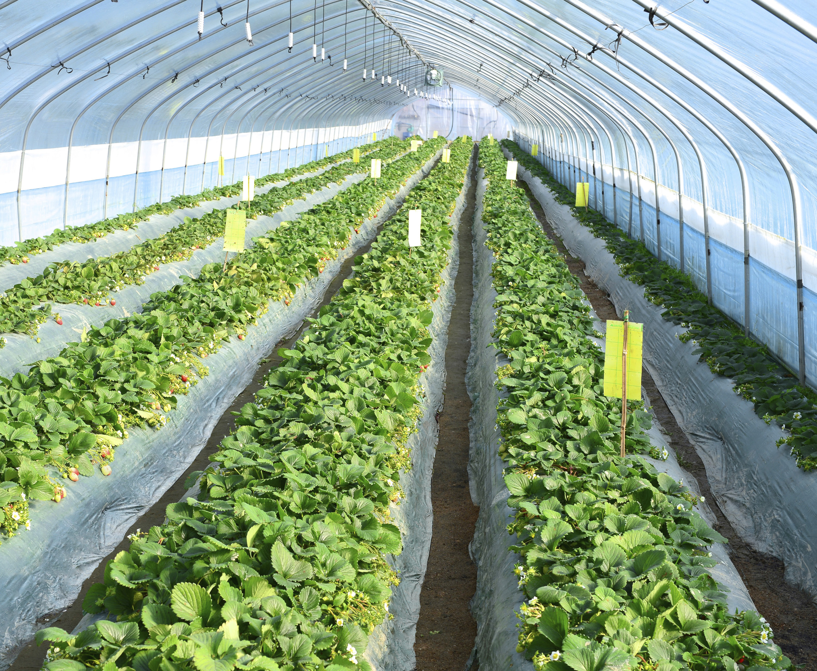
The Alabama Cooperative Extension System (Alabama A&M and Auburn Universities) is an equal opportunity educator and employer. Everyone is welcome to all events!
Download the Farming Basics App to stay connected!
Alabamabeginningfarmer.com
Fall High Tunnel Vegetable Workshop for Small, Beginning, and Experienced Farmers

