21st ANNUAL

SMALL FARMERS
AREA WORK
CONFERENCE
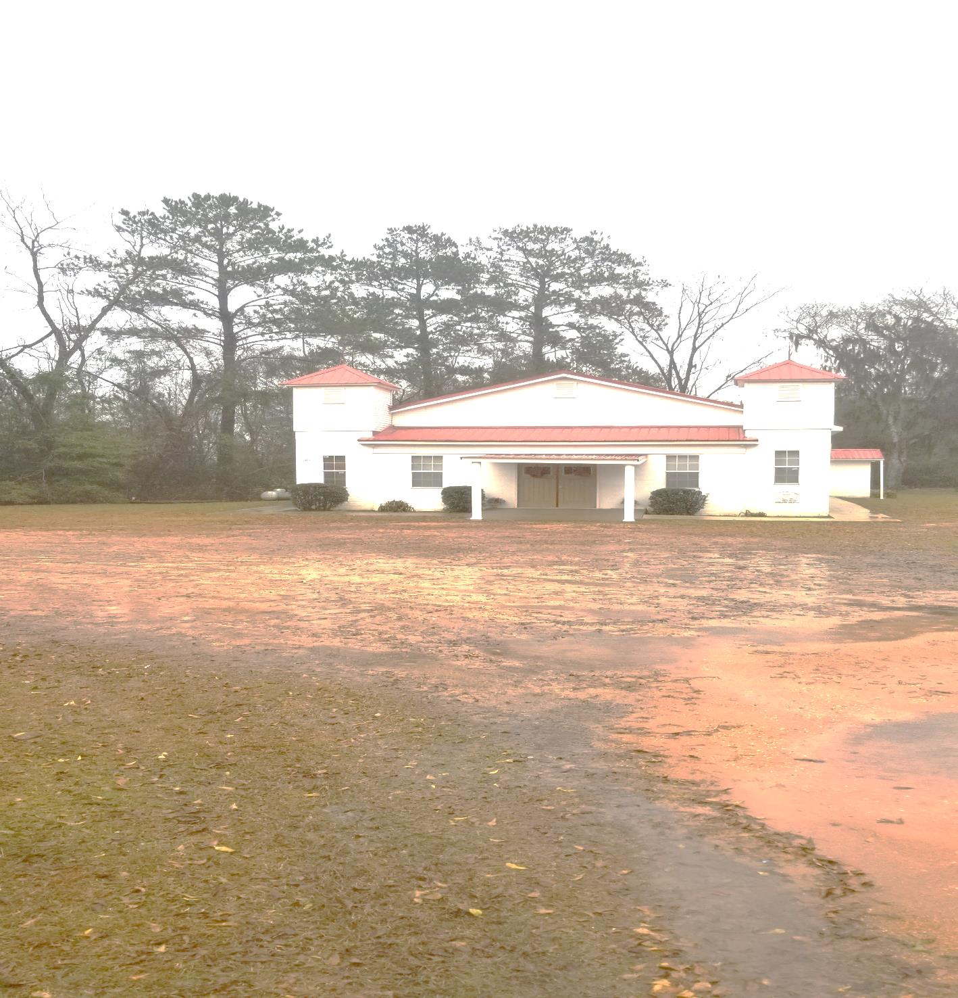
Saturday, February 23, 2019 – 8:00 a.m. – 2:00 p.m.
St. Emanuel Baptist Church #2 -- County Road 12
Coy, Alabama

CONFERENCE OVERVIEW:

USDA UPDATES:
- NAP Program
- Youth Loan
- Cost Share
- Housing

EDUCATIONAL TOPICS:
- Herd Health Education
- Soil Testing Information
- Pasture Management Information
- Timber Management
- Food Safety and Technology for Youth

This is a one-day educational forum that features alternative farming opportunities. Issues will be addressed surrounding small farmers, farm families and rural communities.

CONFERENCE SPONSORS: Tuskegee University Cooperative Extension Program, Natural Resource Conservation Service (NRCS), Wilcox County Cooperative Extension System, Wilcox County Soil & Water Conservation District, USDA Rural Development, Farm Service Agency (FSA), ALA-TOM RC&D, Student Education Enhancement Program (SEEP) The United Christian Community Association (TUCCA), Square O Consulting

Contact Information: Tuskegee University Extension @ (334) 548-2535, Wilcox NRCS @ (334) 682-4116, Andrew Williams @ 334-216-1344 or Thomas Rotschild @ 334-455-0594

Published by the Tuskegee University Cooperative Extension Program, in cooperation with the U.S. Department of Agriculture, Dr. Walter A. Hill, Administrator. The Cooperative Extension Program offers educational programs and materials to all people without regards to race, color, national origin, sex, age, veteran status, or disability. It is also an Equal Employment Opportunity Employer.

