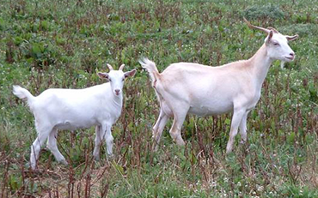

**Farmers Meeting**

Hillsboro Gin and Feed

14934 AL-20, Hillsboro, AL 35643

September 28, 2018

12 Noon til 2 PM

12 Welcome & Blessing Roger Felkins

Hillsboro Gin and Feed

12:10-12:40 Lunch… Goat Stew and Hot Dogs

12:40 Alabama A&M Programs Elicia Chaverest

1:00 NRCS Programs Kathy Gotcher

1:10 Farm Opportunities/ Farm Energy Assessments Mike Roden, AMRV RC&D

1:15 Local Sheep Marketing Charlie Thompson

1:20 Internal Parasites in Ruminants Dr. Cobb

Questions and Comments J.C Holt

1:50 Wrap Up, Evaluations & Questions Mike Roden

aces-c-vert-univ.wmf

Issued in furtherance of Cooperative Extension work, Acts of May 8 and June 30, 1914, in cooperation with

the U.S. Department of Agriculture, by the Alabama Cooperative Extension System (Alabama A&M University and Auburn University).

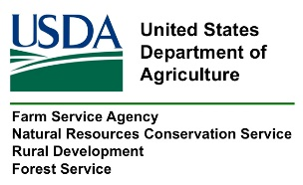USDA is an Equal Opportunity Employer, Provider, and Lender. For additional information or to request special accommodations, contact Mike Roden @ 256-773-8495 five days or more before the desired workshop date.

